# **Introduction to Amazon EC2**

## **Overview**

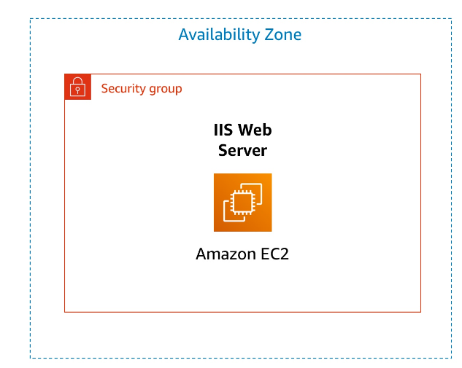

This lab provides you with a basic overview of launching, resizing, managing, and monitoring an Amazon EC2 instance.

**Amazon Elastic Compute Cloud (Amazon EC2)** is a web service that provides resizable compute capacity in the cloud. It is designed to make web-scale cloud computing easier for developers.

Amazon EC2's simple web service interface allows you to obtain and configure capacity with minimal friction. It provides you with complete control of your computing resources and lets you run on Amazon's proven computing environment. Amazon EC2 reduces the time required to obtain and boot new server instances to minutes, allowing you to quickly scale capacity, both up and down, as your computing requirements change.

Amazon EC2 changes the economics of computing by allowing you to pay only for capacity that you actually use. Amazon EC2 provides developers the tools to build failure resilient applications and isolate themselves from common failure scenarios.

### **Topics covered**

By the end of this lab, you will be able to:

* Launch a web server with termination protection enabled
* Monitor Your EC2 instance
* Modify the security group that your web server is using to allow HTTP access
* Resize your Amazon EC2 instance to scale
* Test termination protection
* Terminate your EC2 instance

### **Duration**

This lab takes approximately **45 minutes** to complete.

## **Accessing the AWS Management Console**

1. At the upper-right corner of these instructions, choose **Start Lab**

**Troubleshooting tip**: If you get an **Access Denied** error, close the error box, and choose **Start Lab** again.

1. The lab status can be interpreted as follows:
   * A red circle next to **AWS** at the upper-left corner of this page indicates the lab has not been started.
   * A yellow circle next to **AWS** at the upper-left corner of this page indicates the lab is starting.
   * A green circle next to **AWS** at the upper-left corner of this page indicates the lab is ready.

Wait for the lab to be ready before proceeding.

1. At the top of these instructions, choose the green circle next to **AWS**

This option opens the AWS Management Console in a new browser tab. The system automatically sign you in.

**Tip**: If a new browser tab does not open, a banner or icon at the top of your browser will indicate that your browser is preventing the site from opening pop-up windows. Choose the banner or icon, and choose **Allow pop-ups**.

1. Arrange the AWS Management Console tab so that it displays along side these instructions. Ideally, you should be able to see both browser tabs at the same time so that you can follow the lab steps.

**Do not change the lab Region unless specifically instructed to do so**.

It takes a few minutes to provision the resources necessary to complete this lab.

## **Task 1: Launching your EC2 instance**

In this task, you will launch an Amazon EC2 instance with *termination protection*. Termination protection prevents you from accidentally terminating an EC2 instance. You will deploy your instance with a User Data script that will allow you to deploy a simple web server.

1. In the AWS Management Console on the **Services** menu, choose **EC2**.
2. In the left navigation pane, choose **EC2 Dashboard** to ensure that you are on the dashboard page.
3. Choose **Launch instance**, and then select **Launch instance**.

### **Step 1: Naming your EC2 instance**

When you name your instance, AWS creates a key value pair. The key for this pair is **Name**, and the value is the name you enter for your EC2 instance.

1. In the **Name and tags** pane, in the **Name** text box, enter Web Server.

### **Step 2: Choosing an Amazon Machine Image (AMI)**

An AMI provides the information required to launch an instance, which is a virtual server in the cloud. An AMI includes the following:

* A template for the root volume for the instance (for example, an operating system or an application server with applications)
* Launch permissions that control which AWS accounts can use the AMI to launch instances
* A block device mapping that specifies the volumes to attach to the instance when it is launched

The **Quick Start** list contains the most commonly used AMIs. You can also create your own AMI or select an AMI from the AWS Marketplace, an online store where you can sell or buy software that runs on AWS.

1. Locate the **Application and OS Images (Amazon Machine Image)** pane.
2. Under **AMI Machine Image (AMI)**, notice that the **Amazon Linux 2 AMI** image is selected by default. Keep this setting.

### **Step 3: Choosing an instance type**

Amazon EC2 provides a wide selection of *instance types* optimized to fit different use cases. Instance types comprise varying combinations of CPU, memory, storage, and networking capacity and give you the flexibility to choose the appropriate mix of resources for your applications. Each instance type includes one or more *instance sizes* so that you can scale your resources to the requirements of your target workload.

Select a **t3.micro** instance. This instance type has 2 virtual CPU and 1 GiB of memory.

1. From the dropdown, select **t3.micro**.

**NOTE**: You may be restricted from using other instance types in this lab.

### **Step 4: Configuring a key pair**

Amazon EC2 uses public–key cryptography to encrypt and decrypt login information. To log in to your instance, you must create a key pair, specify the name of the key pair when you launch the instance, and provide the private key when you connect to the instance.

In this lab, you do not log in to your instance, so you do not require a key pair.

1. In the **Key pair (login)** pane, select **Proceed without a key pair (Not recommended)**.

### **Step 5: Configuring the network settings**

You use this pane to configure networking settings.

The **VPC** indicates which virtual private cloud (VPC) you want to launch the instance into. You can have multiple VPCs, including different ones for development, testing, and production.

1. In the **Network settings** pane, choose **Edit**
2. For **VPC - *required***, select **Lab VPC**.
3. Still in the **Network settings** pane, configure the Security Group as follows:
   * **Security group name - *required***: Web Server security group
   * **Description**: Security group for my web server

A *security group* acts as a virtual firewall that controls the traffic for one or more instances. When you launch an instance, you associate one or more security groups with the instance. You add *rules* to each security group that allow traffic to or from its associated instances. You can modify the rules for a security group at any time; the new rules are automatically applied to all instances that are associated with the security group.

1. Under **Inbound security groups rules** select the **Remove**

In this lab, you will not log into your instance using SSH. Removing SSH access will improve the security of the instance.

### **Step 6: Adding storage**

Amazon EC2 stores data on a network-attached virtual disk called Amazon Elastic Block Store (Amazon EBS).

You launch the EC2 instance using a default 8 GiB disk volume. This is your root volume (also known as a boot volume).

1. In the **Configure storage** pane, keep the default storage configuration.

### **Step 7: Configuring advanced details**

1. Expand the **Advanced details** pane.
2. Select the dropdown for **Termination protection**, then choose **Enable**.

When you launch an instance in Amazon EC2, you have the option of passing user data to the instance. These commands can be used to perform common automated configuration tasks and even run scripts after the instance starts.

1. Copy the following commands, and paste them into the **User data** text box.

#!/bin/bash

yum -y install httpdsystemctl enable httpdsystemctl start httpdecho '<html><h1>Hello From Your Web Server!</h1></html>' > /var/www/html/index.html

The script does the following:

* + Install an Apache web server (httpd)
  + Configure the web server to automatically start on boot
  + Activate the Web server
  + Create a simple web page

### **Step 8: Launching an EC2 instance**

Now that you have configured your EC2 instance settings, it is time to launch your instance.

1. In the right pane, choose **Launch instance**
2. Choose **View all instances**

The instance appears in a **Pending** state, which means it is being launched. It then changes to **Running**, which indicates that the instance has started booting. There will be a short time before you can access the instance.

The instance receives a public DNS name that you can use to contact the instance from the Internet.

1. Select the box next to your **Web Server**. The **Details** tab displays detailed information about your instance.

To view more information in the **Details** tab, drag the window divider upward.

Review the information displayed in the **Details, Security** and **Networking** tabs.

1. Wait for your instance to display the following:

**Note:** Refresh if needed.

* + **Instance State:** Running
  + **Status Checks:** 2/2 checks passed

## **Task 2: Monitor Your Instance**

Monitoring is an important part of maintaining the reliability, availability, and performance of your Amazon Elastic Compute Cloud (Amazon EC2) instances and your AWS solutions.

1. Select the instance by checking the box next to the instance and navigate to the bottom of the screen to the **Status checks** tab.

With instance status monitoring, you can quickly determine whether Amazon EC2 has detected any problems that might prevent your instances from running applications. Amazon EC2 performs automated checks on every running EC2 instance to identify hardware and software issues.

Notice that both the **System reachability** and **Instance reachability** checks have passed.

1. Select the **Monitoring** tab.

This tab displays Amazon CloudWatch metrics for your instance. Currently, there are not many metrics to display because the instance was recently launched.

You can choose a graph to see an expanded view.

Amazon EC2 sends metrics to Amazon CloudWatch for your EC2 instances. Basic (five-minute) monitoring is enabled by default. You can enable detailed (one-minute) monitoring.

1. In the **Actions**  menu, select **Monitor and troubleshoot** **Get Instance Screenshot**.

This shows you what your Amazon EC2 instance console would look like if a screen were attached to it.

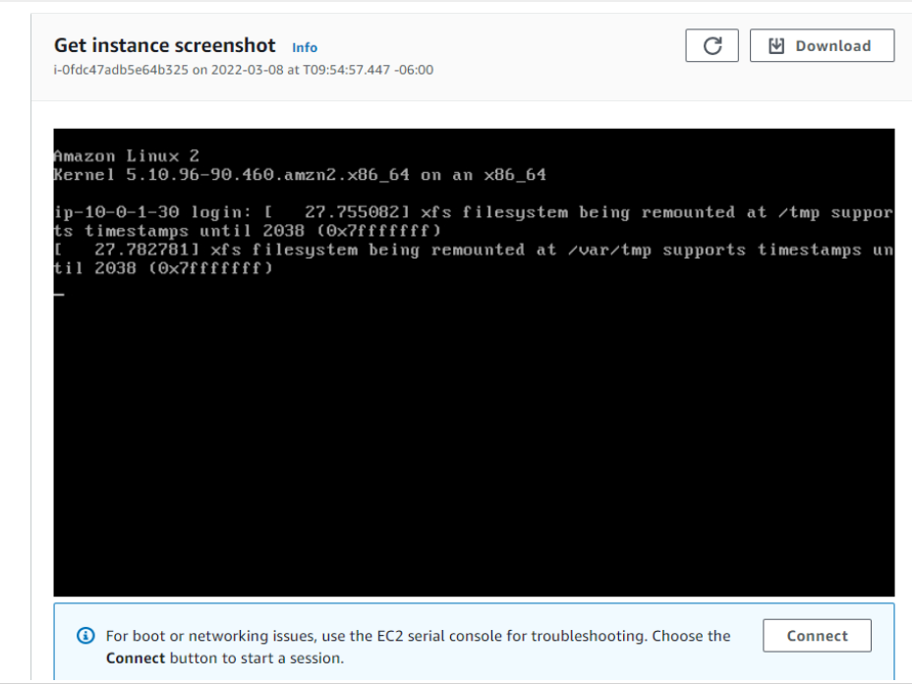

If you are unable to reach your instance via SSH or RDP, you can capture a screenshot of your instance and view it as an image. This provides visibility as to the status of the instance, and allows for quicker troubleshooting.

1. Select **Cancel** located at the bottom of the instance screenshot.

**Congratulations!** You have explored several ways to monitor your instance.

## **Task 3: Update Your Security Group and Access the Web Server**

When you launched the EC2 instance, you provided a script that installed a web server and created a simple web page. In this task, you will access content from the web server.

1. Select the instance by checking the box and select the **Details** tab.
2. Copy the **Public IPv4 address** of your instance to your clipboard.
3. Open a new tab in your web browser, paste the IP address you just copied, then press **Enter**.

**Question:** Are you able to access your web server? Why not?

You are **not** currently able to access your web server because the *security group* is not permitting inbound traffic on port 80, which is used for HTTP web requests. This is a demonstration of using a security group as a firewall to restrict the network traffic that is allowed in and out of an instance.

To correct this, you will now update the security group to permit web traffic on port 80.

1. Keep the browser tab open, but return to the **EC2 Management Console** tab.
2. In the left navigation pane, select **Security Groups** located under **Network & Security**.
3. Select **Web Server security group**.
4. Select the **Inbound rules** tab.

The security group currently has no rules.

1. Select **Edit inbound rules** then select **Add rule** and configure the rule with the following settings:
   * **Type:** *HTTP*
   * **Source:** *Anywhere-IPv4*
   * Select **Save rules**
2. Return to the web server tab that you previously opened and refresh the page.

You should see the message *Hello From Your Web Server!*

**Congratulations!** You have successfully modified your security group to permit HTTP traffic into your Amazon EC2 Instance.

## **Task 4: Resize Your Instance: Instance Type and EBS Volume**

As your needs change, you might find that your instance is over-utilized (too small) or under-utilized (too large). If so, you can change the *instance type*. For example, if a *t3.micro* instance is too small for its workload, you can change it to an *m5.medium* instance. Similarly, you can change the size of a disk.

### **Stop Your Instance**

Before you can resize an instance, you must *stop* it.

When you stop an instance, it is shut down. There is no charge for a stopped EC2 instance, but the storage charge for attached Amazon EBS volumes remains.

1. On the **EC2 Management Console**, in the left navigation pane, select **Instances**.

**Web Server** should already be selected.

1. Select **Instance state > Stop instance**.
2. Select **Stop**

Your instance will perform a normal shutdown and then will stop running.

1. Wait for the **Instance State** to display: stopped

### **Change The Instance Type**

1. In the **Actions**  menu, select **Instance Settings** **Change Instance Type**, then configure:
   * **Instance Type:** *t3.small*
   * Select **Apply**

When the instance is started again it will be a *t3.small*, which has twice as much memory as a *t3.micro* instance. **NOTE**: You may be restricted from using other instance types in this lab.

### **Resize the EBS Volume**

1. In the left navigation menu, select **Volumes** located under **Elastic Block Store**.
2. Select the volume by checking the box, and navigate to the **Actions**  menu, select **Modify Volume**.

The disk volume currently has a size of 8 GiB. You will now increase the size of this disk.

1. Change the size to: 10 **NOTE**: You may be restricted from creating large Amazon EBS volumes in this lab.
2. Select **Modify**
3. Select **Modify** to confirm and increase the size of the volume.

### **Start the Resized Instance**

You will now start the instance again, which will now have more memory and more disk space.

1. In left navigation pane, select **Instances**.
2. Select the **Web Server** instance by checking the box, then navigate to **Instance state > Start instance**.

**Congratulations!** You have successfully resized your Amazon EC2 Instance. In this task you changed your instance type from *t3.micro* to *t3.small*. You also modified your root disk volume from 8 GiB to 10 GiB.

## **Task 5: Test Termination Protection**

You can delete your instance when you no longer need it. This is referred to as *terminating* your instance. You cannot connect to or restart an instance after it has been terminated.

In this task, you will learn how to use *termination protection*.

1. In left navigation pane, select **Instances**.
2. Select the **Web Server** instance by checking the box and navigate to the top and select **Instance state**  menu, select **Terminate instance**.

Note: There is a message that says: *On an EBS-backed instance, the default action is for the root EBS volume to be deleted when the instance is terminated. Storage on any local drives will be lost.* It will ask if you are sure that you want to terminate the instance. You will be able to select the **Terminate** button.

Note: You will notice that the instance did not terminate and a red error message pops up at the top that says: *Failed to terminate an instance: The instance may not be terminated.* This is because it has termination protection enabled.

1. In the **Actions**  menu, select **Instance settings** **Change termination protection**.
2. Uncheck **Enable** followed by **Save**

You can now terminate the instance.

1. In the **Actions**  menu, select **Instance State** **Terminate instance**.
2. Select **Terminate**

**Congratulations!** You have successfully tested termination protection and terminated your instance.

## **Lab Complete**

1. Choose **End Lab** at the top of this page, and then select **Yes** to confirm that you want to end the lab.

A panel indicates that *DELETE has been initiated... You may close this message box now.*

1. A message *Ended AWS Lab Successfully* is briefly displayed, indicating that the lab has ended.

## **Additional Resources**

* [Launch Your Instance](https://docs.aws.amazon.com/AWSEC2/latest/UserGuide/LaunchingAndUsingInstances.html)
* [Amazon EC2 Instance Types](https://aws.amazon.com/ec2/instance-types)
* [Amazon Machine Images (AMI)](https://docs.aws.amazon.com/AWSEC2/latest/UserGuide/AMIs.html)
* [Amazon EC2 - User Data and Shell Scripts](https://docs.aws.amazon.com/AWSEC2/latest/UserGuide/user-data.html)
* [Amazon EC2 Root Device Volume](https://docs.aws.amazon.com/AWSEC2/latest/UserGuide/RootDeviceStorage.html)
* [Tagging Your Amazon EC2 Resources](https://docs.aws.amazon.com/AWSEC2/latest/UserGuide/Using_Tags.html)
* [Security Groups](https://docs.aws.amazon.com/AWSEC2/latest/UserGuide/using-network-security.html)
* [Amazon EC2 Key Pairs](https://docs.aws.amazon.com/AWSEC2/latest/UserGuide/ec2-key-pairs.html)
* [Status Checks for Your Instances](https://docs.aws.amazon.com/AWSEC2/latest/UserGuide/monitoring-system-instance-status-check.html?icmpid=docs_ec2_console)
* [Getting Console Output and Rebooting Instances](https://docs.aws.amazon.com/AWSEC2/latest/UserGuide/instance-console.html)
* [Amazon EC2 Metrics and Dimensions](https://docs.aws.amazon.com/AmazonCloudWatch/latest/monitoring/ec2-metricscollected.html)
* [Resizing Your Instance](https://docs.aws.amazon.com/AWSEC2/latest/UserGuide/ec2-instance-resize.html)
* [Stop and Start Your Instance](https://docs.aws.amazon.com/AWSEC2/latest/UserGuide/Stop_Start.html)
* [Terminate Your Instance](https://docs.aws.amazon.com/AWSEC2/latest/UserGuide/terminating-instances.html)
* [Termination Protection for an Instance](https://docs.aws.amazon.com/AWSEC2/latest/UserGuide/terminating-instances.html)

For more information about AWS Training and Certification, see <https://aws.amazon.com/training/>. *Your feedback is welcome and appreciated.* If you would like to share any suggestions or corrections, please provide the details in our [AWS Training and Certification Contact Form](https://support.aws.amazon.com/#/contacts/aws-training). *© 2023 Amazon Web Services, Inc. and its affiliates. All rights reserved. This work may not be reproduced or redistributed, in whole or in part, without prior written permission from Amazon Web Services, Inc. Commercial copying, lending, or selling is prohibited.*